Math/Stat 170 Lab Project 1 August 31, 2006

Introduction to Excel

Part 1: You will be given a function (mortality function) that defines the probability of death in any given year and from that you will create a mortality table in Excel. In this project, we assume initially that probability of death in any year is (X +1)³/ (100)³ where X is the age of the person. Thus, for example, we are saying that the probability of a 20 year old dieing during a given year is (21)³/(100)³=0.009261 while for a 99 year old the probability is (100)³/(100)³=1 . Hence, by age 100, you are certainly dead. This probability of death has no basis in reality, so do not draw any conclusions about anybody's chance of living or dying from this Lab.

To construct the mortality table, we assume an initial population (the radix) of 1000000 individuals. Our mortality table will list for each age from 0 to 100 (a) the probability that an individual that age dies (probability of death), (b) the number of individuals from the original group of 1000000 that are still alive (lives), (c) the number of individuals who die during the year (deaths) and (d) the life expectancy of an individual that age (expectation of life). The following instructions tell how to compute these quantities.

Part 2: You will be given an individualized mortality function and you will need to create a mortality table based on this function.

Detailed Instructions: Part 1

- Login and select "All Programs - Standard Software - Microsoft Office -Microsoft Excel"

- After Excel has started, an Excel spreadsheet will nearly fill the screen. There are letters across the top of the spreadsheet and numbers down the left side. The rectangles that are in the spreadsheet, called “cells", are labeled according to the letters and numbers at the edge: Cell “C4" is the rectangle under the “C” and to the right of the “4". If you click in a cell, it becomes active: you can type in it or in the box just above the spreadsheet, and you can type either text or formulas into the cell.

Note: “###” in a cell indicates an error. Often, the problem is that the column is too narrow to hold the data. Double clicking with the cursor on the right edge of the gray area at the top of a column causes the column to adjust its width. Another common cause for this message is forgetting to begin a formula with an equal sign. (All formulas must begin with “=”.) Finally, this message often appears temporarily when copying formulas into cells where the data needed to compute the result hasn't been entered yet.

- Type exactly what is indicated in the first picture on fourth page of this project in the indicated cell. What Excel actually displays should look something like the second picture. (These pictures may look slightly different due to a different computer.) Your name, the Lab number, and the date should always be included in the upper left hand corner of every lab assignment as indicated on the enclosed page.

Tip: You can highlight a cell or group of cells and then format those cells. Certain formatting capabilities are contained in the buttons on the top of the screen while others are accessed by left clicking on the “Format” option in the menu. You can highlight a whole row or column by clicking onto the gray area at the edge or top.

- Enter “Purdue Mortality Table” (without the quotes) in cell A7. Enter the appropriate headers as shown in the second picture on page 4 in cells A9 through E10.

Note: When you first enter the headers, they will look different from the picture. The ones in the picture have been formatted. While instructions are not here on how to format the headers, we will do this in class.

- Enter a 0 (zero) in Cell A12.
- In Cell A13 enter “=A12+1” (without the quotes) and hit enter. This formula takes the value in Cell A12 and adds 1 to it. Please note the = to start the formula. The = tells Excel that you are entering a formula. Also note that when you entered your headers, you did not enter an =. Your screen should now look like the third picture below.
- Now copy the formula from Cell A13 into Cells A14 to A111. Cell A111 should equal 99.

Tip: You can copy by right clicking a cell and selecting copy. Then, highlight an area by left clicking and holding it down while you drag your mouse over the area that you want to copy into. Right click the highlighted area and select paste. There are other ways that we will discuss in class.

- Enter the formula shown in the fourth picture below into B12. This is the formula for the probability of death given above.

Note: The ^ is used to indicate an exponential. The two sets of parenthesis are necessary to assure the correct order of calculation.

- Copy the formula from B12 to B13 through B111
- Enter 1000000 into cell C12, which is the number of people assumed to be living at time 0. (It is called the radix. ) In Cell D12 enter the formula shown in the fifth picture below and hit enter. To determine the number of deaths at any age we have to multiply the number of people alive by the probability of death. This is what this formula does.

Note: An * is used as a multiplication sign.

- If there are 1,000,000 people alive at age 0 (Cell C12) and 1 person dies (Cell D12) die, how many are alive at age 1. Enter a formula in Cell C13 that accomplishes this calculation.
- Copy the contents of C13 into Cells C14 to C111. Copy the contents of D12 into Cells D13 to D111. Your spreadsheet should look like picture 6 below.
- All that is left is to calculate the expectation of life. The expectation of life for a person of a particular age is the average number of years that an individual of that age form our population group lives. Experimentally, it could be found by tracking, say, 100 people of that age until they all die, recording how many die at each age. One then subtracts the beginning age from the average age of death. If, for example, in a group of 100 (extremely unhealthy) 20 year olds, 10 die at age 20, 30 at age 21, and 60 at age 22, then the average age of death is
(20*10+21*30+22*60)/100
=20*.1+21*.3+22*.6=21.5

Hence the life expectancy is 1.5 years.

In our spread sheet, to find the average age of death for an individual of age x, we sum (age of death) times (deaths) from year x to the end of the table and divide by the number of individuals alive in year x. The life expectation is then obtained by subtracting x. To facilitate the computation we compute (age of death) times (deaths) in a separate column.

Note: There are several things about the formula in cellF12 that is different. First, it uses a function (sum). This function tells Excel to sum the cells included in the parenthesis. Excel has several functions built in. We will explore more of these functions as the semester progresses. The second difference in this formula is the appearance of a $. In Excel, a cell reference is considered relative unless you tell it that it is fixed. The $ is used to tell Excel that a cell reference in a formula is fixed. We will discuss this more in class. Finally, the / is used to indicate division.

- Copy Cells E12 to Cells E13 to E110.
- Format the cells to look like picture 10 below and you are done with Part 1.

Part 2

- Redo the above exercise in “Sheet 2” using your personalized probability of death. Your personalized probability of death is ((X² + X +100)/10000)^{Y} were X is age and Y is the constant assigned to you in the "Lab 1 Individualized Data" file on the web..

Note: You can create additional sheets in Excel using the insert menu at the top of the window. You can copy the entire sheet by right clicking the box in the upper left hand corner (above row 1 and to the left of column A) and selecting paste. Go to the bottom and click on a new sheet and then right click the same box and select paste.

- When you have finished the project, save your work by choosing “Save As" from the File menu. In the “Save As" dialog box, you will be able to rename the file: call it “Lastname_Firstname_lab#.xls" Important! Notice where it is being saved! At the top of the dialog box, there will be the name of a folder (a directory): it will be saved in this directory. If you want to see the entire path, click on the arrow beside the folder name and hold the mouse button down; you will see the nested folders that will contain your new file after you click “Save"; if you do not want to save in this location (you probably don't want to!), navigate to where you want to save it. For example, if you want to save it in your career account or a floppy disk, move the mouse to the connection to your career account directory or “Floppy (:A)", etc. Click “Save" to save it with the name and location shown. Quit Excel by choosing “Exit" from the bottom of the File menu. When you have finished, close and close anything you have open and Logout.
- Upload the completed project to Blackboard prior to the deadline indicated in Blackboard following the instructions in the “Instructions for submitting labs” found on the course web page.

Key Vocabulary Terms:

Probability of Death
Mortality Table
Radix
Expectation of Life

Picture 1
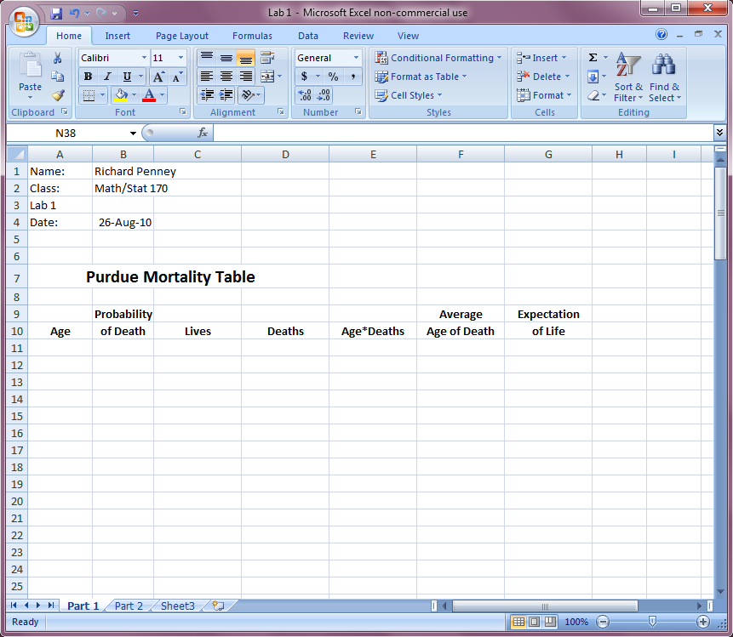

Picture 2
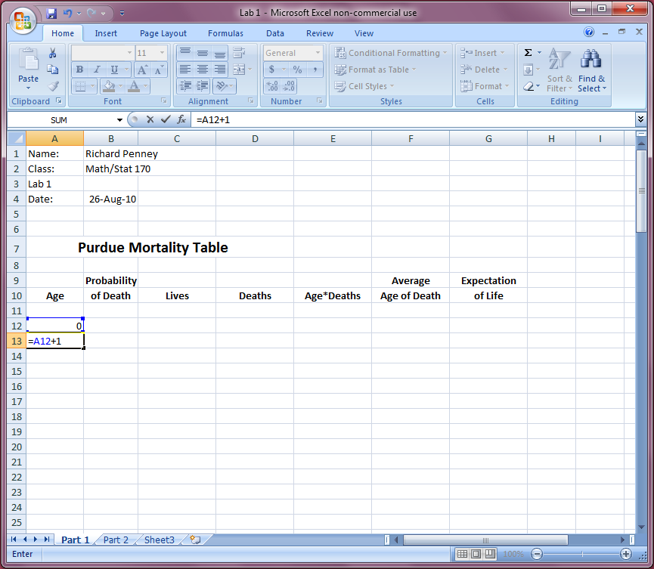

Picture 3
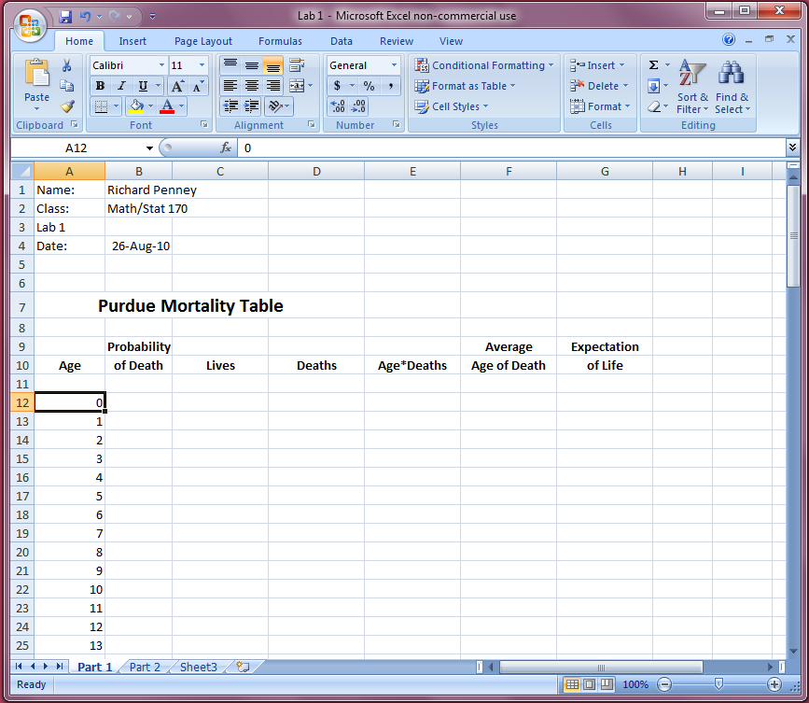

Picture 4
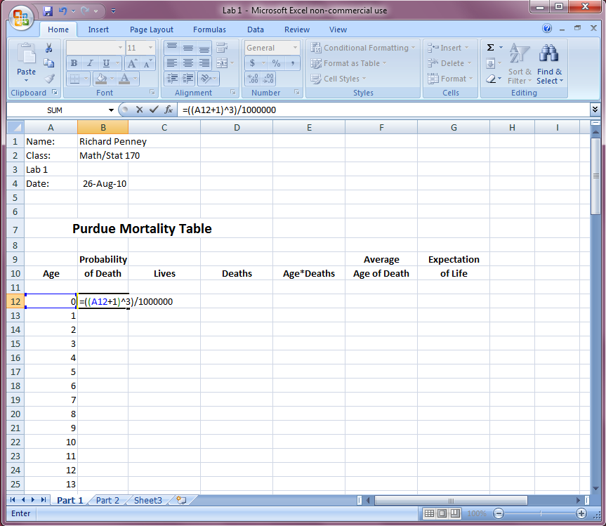

Picture 5
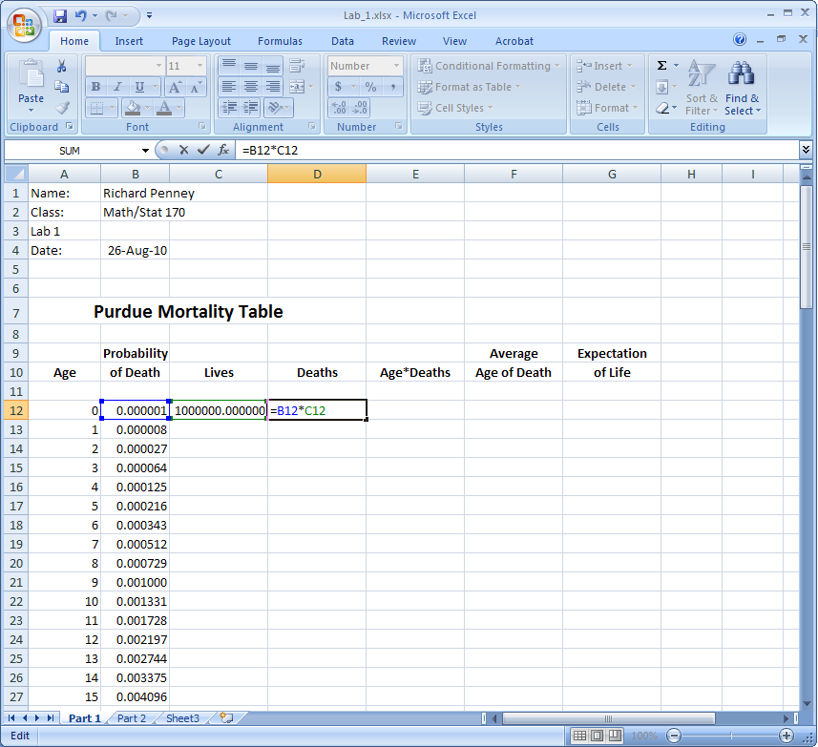

Picture 6
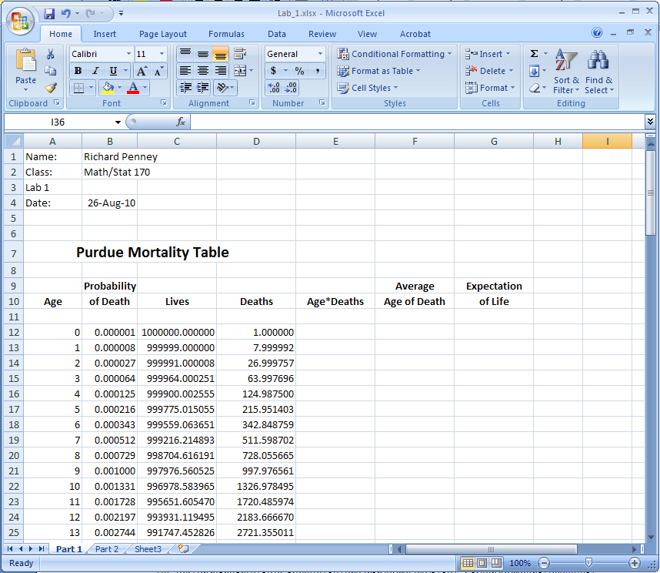

Picture 7
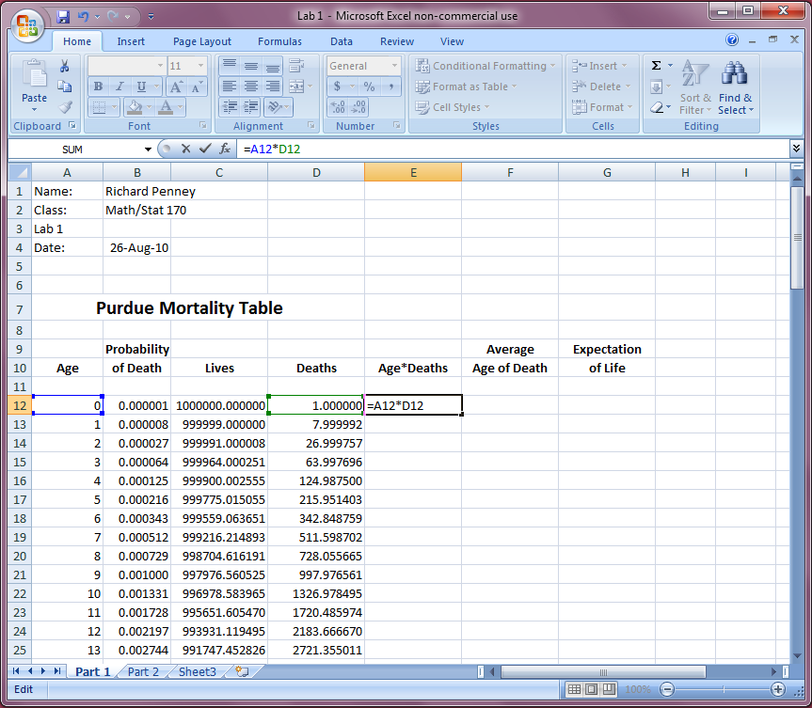

Picture 8
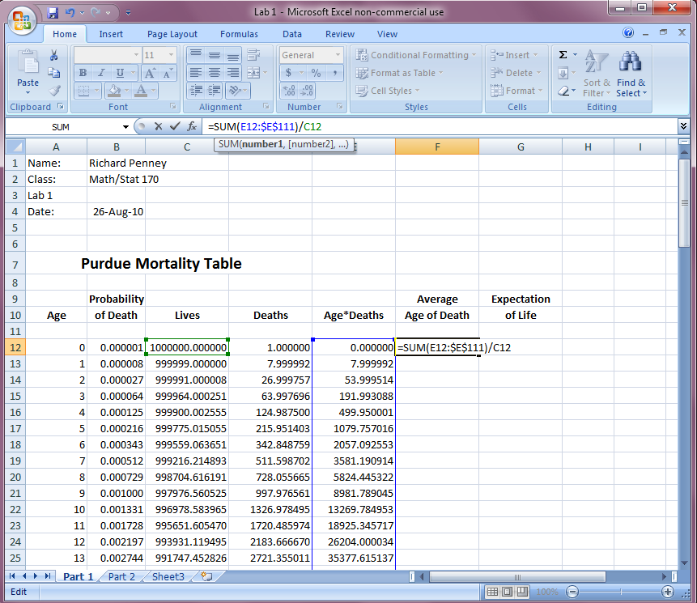

Picture 9
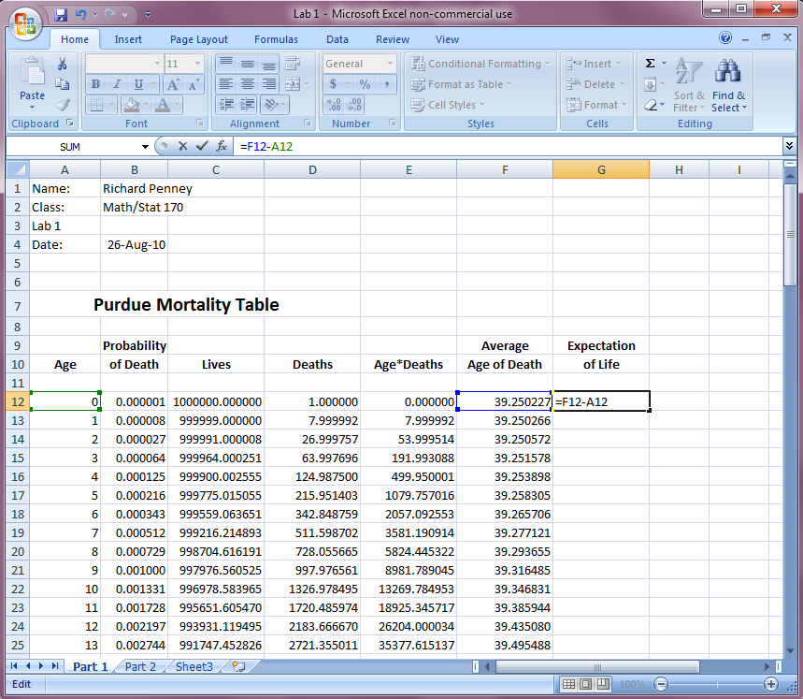
Picture 10